**EXPERIMENT-4**

**AIM:**  
To study the charging and discharging of a capacitor and to find out time constant

**APPARATUS:**

Charging and discharging of capacitor experimental setup.

**THEORY:**

In case of charging, the voltage across capacitor is givers

by following egn

V = Vol-e-t/Re]

when t = RC = 12 = time constant)

verol l-e-) = Volda

V= 0.632 VO

So in case of charging the time constant is the time when

the voltage across capacitors is 01632_time of maximum volatage.

In case of discharging, the voltage across capacitor is

given by following equation

V = vo e t/Rc

when t = RC = 2

2 = time constant, then

Va Voe Vole.

[V=0.368 V)

So in case of discharging

the time constant is the time

why voltage across tåpocitos vs 0.368 times of its maximum

Voltage

**DIAGRAM**

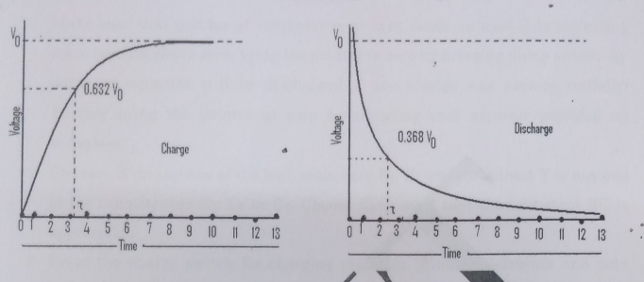

**PROCEDURE-**

1. Make sure that pointer of voltmeter is at zero mark. In case it is indicating

some reading above zero, bring the pointer to zero by pressing dump switch. By doing so capacitor will be discharged if any charge was present initially.

Further bring the pointer at zero by adjusting zero adjustor provided on

Voltmeter.

2. Connect X to any one of the high resistance R1, R2 and R3 connect Y to any one of the capacitances C1, C2 or C3. Choose R1,Ci such that time constant RC is appreciable

3. Press the charge switch for charging capacitor through resistance and note down the reading of voltmeter after every 5 to 10 seconds repeating same procedure till capacitor is almost fully charged. See the example after the observation table. It is better to take the time corresponding to changing voltmeter reading (OV1, 1.2V1)

4. When capacitor attains full charge. Bring the switch towards discharge and note down voltmeter reading of voltmeter even 5 to 10 seconds till the

discharged.

5. Now plot curve on charge and discharge saking suitable scale. Time is plotted on X-axis while Voltage on Y-axis.

6. Measure the input voltage Vo since you know it you don't need to charge the capacitor fully to find it.

**DETERMINATION OF TIME CONSTANT**

Suppose 4700ufd i.e 4700 x 10-6 farad capacitor is charged through a 10000 Ohm

resistor. The voltage on capacitor shall reach 63% of applied voltage after CR

seconds(Time Constant) i.e.4700 x 106 x 104 or 47 seconds. The value of time

constant may also be verified by charge and discharge curves. Suppose highest

voltage across capacitor is 10 volts. The time taken to charge it upto 6.3 V (63% of 10 volts) may be determined by drawing a straight line parallel to X-axis at 6.3V and

find out corresponding value of time. Similarly during discharge value of time

constant may be find out by drawing a line parallel to X-axis at 6.3V (37% loss of 10

Volts or 6.3V).

**DIAGRAM**

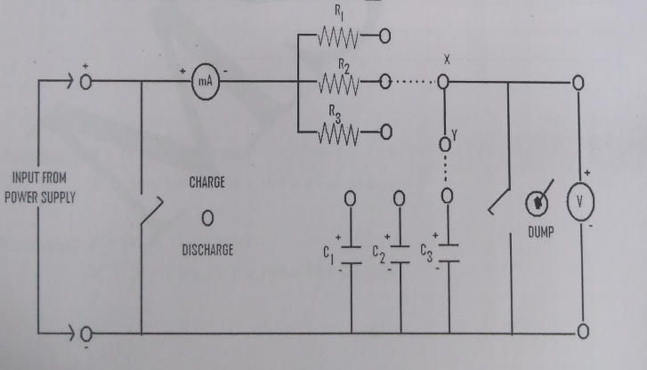

**OBSERVATION TABLE**

|  |  |  |  |  |  |  |  |  |  |  |  |  |  |  |  |  |  |  |  |  |  |  |  |  |  |  |  |  |  |  |  |  |  |  |  |  |  |  |  |  |  |  |  |  |  |  |  |  |  |  |  |  |
| --- | --- | --- | --- | --- | --- | --- | --- | --- | --- | --- | --- | --- | --- | --- | --- | --- | --- | --- | --- | --- | --- | --- | --- | --- | --- | --- | --- | --- | --- | --- | --- | --- | --- | --- | --- | --- | --- | --- | --- | --- | --- | --- | --- | --- | --- | --- | --- | --- | --- | --- | --- | --- |
| **S.NO**   |  | | --- | |  | |  | |  | |  | |  | |  | |  | |  | |  | |  | | **CHARGING**  **VOLTAGE(V) TIME(sec)**   |  |  | | --- | --- | |  |  | |  |  | |  |  | |  |  | |  |  | |  |  | |  |  | |  |  | |  |  | |  |  | | **DISCHARGING**  **VOLTAGE(V) TIME(sec)**   |  |  | | --- | --- | |  |  | |  |  | |  |  | |  |  | |  |  | |  |  | |  |  | |  |  | |  |  | |  |  | |

**RESULT**

The time constant from the graph is

The time constant from theory is

**PRECAUTIONS:-**

1. Condensers should not be leaky.

2. Appropriate value of R and C given, quite a good number of observations

should be used

3. There should be carefully connections.

.